Annual Report for the Academic Year 2022-2023
4.2—Accountability Measures as Required by CAEP for CHEA Requirements
(R4.2) Measure 2 (Initial): Satisfaction of Employers and Stakeholders
As with the Completer Survey, a similar survey has been administered to employers of the 2022-2023 completers. The EPP sent out the survey to 31 employers and received 10 responses, a 30.3% return rate. While this return rate is lower than the return rate for completers, this is still a strong sample size of those who employ the EPP’s completers. In Chart O, the responders indicated their level of satisfaction with the EPP’s completers. Of the 10 responders, 8 indicated they were “Very Satisfied” and 2 indicated that they were “Satisfied.” Thus, 80% of responders were highly satisfied with the EPP’s completers and 20% were satisfied. This indicates that the EPP has a 100% satisfaction rate for its completers, based on those responders to the survey.
Chart O

The employers were asked to respond on the survey to the following questions, which are identical to those asked of the completers, in order to determine the effectiveness of completer impact on student growth and achievement.
- Understand how individual differences and diverse cultures impact student learning and classroom environments and use that information to design and deliver instruction
- Plan and deliver differentiated instruction using a wide range of evidence-based instructional strategies, resources, and technological tools to meet the diverse learning needs of GIFTED STUDENTS
- Plan and deliver differentiated instruction using a wide range of evidence-based instructional strategies, resources, and technological tools to meet the diverse learning needs of STUDENTS WITH DISABILITIES
- Plan and deliver differentiated instruction using a wide range of evidence-based instructional strategies, resources, and technological tools to meet the diverse learning needs of ENGLISH LANGUAGE LEARNERS
- Plan and deliver differentiated instruction using a wide range of evidence-based instructional strategies, resources, and technological tools to meet the diverse learning needs of AT-RISK STUDENTS
- Recognize student misconceptions and create experiences to build accurate conceptual understandings
- Create opportunities for students to learn, practice, and master academic language
- Use academic language in a way that encourages learners to integrate content areas
- Utilize strategies to create learning environments which engage students in individual and collaborative learning
- Engage learners in understanding, questioning, analyzing ideas and content from diverse perspectives
- Develop supports for literacy development across content areas
- Seek appropriate ways to integrate technology to support assessment practice and to assess learner needs
- Use formative and summative data to adjust instruction to enhance learning
- Align instructional goals and activities with state and district performance standards
- Use ongoing analysis and reflection to improve planning and practice
Employer responses to these 15 items are found in Chart P. Categories 1-15 correspond to the numbers listed above next to each item.

Chart P

Data gleaned from the employer survey for the 15 items identified in Chart P provides an overall view of employer perception of completers’ impact on P-12 student growth and achievement. All had a weighted average on the 3-point scale of 2.0 or above. The highest weighted averages were the following, with the weighted average provided in parentheses:
- Plan and deliver differentiated instruction using a wide range of evidence-based instructional strategies, resources, and technological tools to meet the diverse learning needs of English language learners (2.50)
- Create opportunities for students to learn, practice, and master academic language (2.50)
- Use academic language in a way that encourages learners to integrate content areas (2.50)
- Utilize strategies to create learning environments which engage students in individual and collaborative learning (2.50)
- Align instructional goals and activities with state and district performance standards (2.50)
Comparing the weighted averages of the employers in Chart P to the weighted averages of the completers from Chart A, both completers and employers found the completer able to utilize academic language as well as teach their students to learn, practice, and mastery academic language. The average for completers in the ability to create opportunities for students to learn, practice, and master academic language was 2.62, compared to the employer average of 2.50. As well, completers averaged 2.62 on Item #8: “Use academic language in a way that encourages learners to integrate content areas,” while employers averaged 2.50 on the 3-point scale.
There was one relatively lower weighted average from the Employer Survey. Item #3: “Plan and deliver differentiated instruction using a wide range of evidence-based instructional strategies, resources, and technological tools to meet the diverse learning needs of students with disabilities” had one employer who marked “Disagree.” While this was one only employer out of the ten who responded to the survey, it is important to note that the completers surveyed did not have any completer who rated this item negatively. The EPP will continue to monitor this item and include in its discussions with faculty of the curriculum map the undergraduate committee has developed to ensure more opportunities for planning for diverse learners are available. Additionally, the reconstruction of the EPP’s lesson plan template and rubric requires more differentiation to be embedded in lesson plans.
Data were compared from the Completer and Employer Surveys that evaluated completers’ impact on P-12 student growth and achievement using a two-tailed, paired t-test for the weighted averages of all relevant responses, provided in Table 1. Based upon the t-test results, there was statistically significant difference between the mean of the weighted averages of completer responses and the mean of the weighted averages of the employer responses at p$<$.05, where t=3.8914, p=0.0016.

Table 1
Group | Completers | Employers
Mean | 2.5127 | 2.4027
Standard Deviation | 0.0971 | 0.0932
Standard Error of Mean | 0.0251 | 0.0241
N | 15 | 15

With the difference between completer and employer survey ratings being statistically significant, the EPP will review these data as a faculty. It is important to ensure that the EPP’s completers are able to reflect accurately on their practice and skills. More opportunities for reflective practice would be beneficial to the EPP’s completers.
Chart Q provides side-by-side weighted averages of the completers and employers respectively on the 15 items that measure completer impact on P-12 student growth and achievement.

Chart Q

Employers overall reported that they were satisfied with the EPP completers, but there are areas for growth for both the completers and the EPP. Areas of growth include in differentiating instruction for English language learners and students with disabilities. The EPP have addressed these areas by reconstructing the lesson plan template used by all EPP teacher candidates. The newly constructed lesson plan template requires the teacher candidates to differentiate instruction for English language learners and students with disabilities, as well as plan how they will differentiate instruction to challenge and support gifted students and identify and support at-risk students. The EPP will present its construction of a curriculum map to EPP faculty where the EPP can determine where more instruction and practice in differentiating instruction for all learners can be added.
Measure 2 (Advanced): Satisfaction of Employers and Stakeholder Involvement. (R4.2/R5.3/RA4.1)
Impact on P-12 Learning and Development – Initial Licensure: School Psychology

Satisfaction of Employers
The Specialist in School Psychology at FMU sent a questionnaire to 10 employers of our previous completers (academic year 2022-2023) who are in their first year as practicing school psychologists (2023-2024). The EPP received 4 responses (40% return rate).

It should be noted that all of our candidates were offered employment in the district where they completed their internships, and nine were ultimately hired immediately after their year-long internships. This indicates that the employers were pleased with our candidates and felt they would be a good fit for continued employment. Additionally, all of these employers requested interns for the 2023-2024 school year and have asked for other graduates who are not interning with them to apply for open positions. This also indirectly indicates a high level of satisfaction with our graduates.
Initially, the questionnaire asked completers to respond to 14 rating scale items determined by the EPP to give insight into completer impact on the satisfaction of employers (4.2). For the 2021-2022 academic year, an additional rating question was added to the questionnaire to address directly employer satisfaction with completers of Francis Marion University’s graduates. In 2022-2023, three additional open-ended items were added to provide specific information regarding strengths, areas of improvement, and other general comments about the program. Demographic questions also help us determine how many school psychologists graduated from the FMU program and how many psychologists they have in their district.
The EPP reviewed the survey items and then used Lawshe's Content Validity Formula (Lawshe, C.H. (1975) to determine which items were associated with the duties required of school psychologists and other professional dispositions that are associated with employer satisfaction. The following items were initially identified, and employers were asked to respond to each of these items with one of the following options: Strongly Agree (SA=4), Agree (A=3), Disagree (D=2), and Strongly Disagree (SD=1):
- Knowledge of varied models and methods of assessment and data collection for identifying strengths and needs, developing effective services and programs, and measuring progress and outcomes. (2.1)
- Ability to interpret and report results of problem analysis/psychoeducational assessments and link results to intervention as needed (including the ability to interpret results in a fair and accurate manner, report results to others in a meaningful way that facilitates appropriate interventions, and use results for decision making that fosters positive outcomes for students/clients). (2.1)
- Knowledge of varied models and strategies of consultation, collaboration, and communication applicable to individuals, families, schools, and systems, and methods to promote effective implementation of services. (2.2)
- Knowledge of biological, cultural, and social influences on academic skills; human learning, cognitive and developmental processes; and evidence-based curricula and instructional strategies. (2.3)
- Core knowledge of biological, cultural, developmental and social influences on behavior and mental health, behavioral and emotional impacts on learning and life skills, and evidence-based strategies to promote social-emotional functioning, and mental and behavioral health. (2.4)
- Core knowledge of school and systems structure, organization, and theory; general and special education; technology resources; and evidence-based school practices that promote learning and mental and behavioral health. (2.5)
- Core knowledge of principles and research related to resilience and risk factors in learning and mental health, services in schools and communicates to support multitiered prevention, and evidence-based strategies for effective crisis response. (2.6)
- Core knowledge of principles and research related to family systems, strengths, needs, and culture; evidence-based strategies to support family influences on children's learning and mental and behavioral health; and strategies to develop collaboration between families and schools. (2.7)
- Core knowledge of individual differences, abilities, disabilities, and other diverse student characteristics; principles and research related to diversity factors of children, families, and schools, including factors related to culture, context, and individual and role difference; and evidence-based strategies to enhance services and address potential influences related to diversity. (2.8)
- Core knowledge of research design, statistics, measurement, varied data collection and analysis techniques, and program evaluation sufficient for understanding research and interpreting data in applied settings. (2.9)
- Core knowledge of the history and foundations of school psychology; multiple service models and methods; ethical, legal, and professional standards; and other factors related to professional identity and effective practice as school psychologists. (2.10)
- Professional integrity, involvement, and leadership (including adherence to ethical/legal standards, participation in professional development activities, and demonstration of leadership skills within the district/agency, community, and/or profession). (PROF)
- Personal/professional work qualities needed for effective interaction with others (including respect for worth and uniqueness of all individuals of varying abilities and disabilities regardless of cultural, ethnic, socioeconomic, gender and religious backgrounds, ability to interact effectively with children, adults, and families of diverse backgrounds, and ability to establish and maintain collaborative relationships with colleagues/coworkers). (PROF)
- How well did FMU appear to provide the training needed for your employees to provide quality services that positively impact children and other clients? (PROF)
Additionally, the employers were asked to respond to this item with one of the following options, using one of the following options: Strongly Satisfied (SA=4), Satisfied (A=3), Dissatisfied (D=2), and Strongly Dissatisfied (SD=1).
15. How satisfied are you with the first-year school psychologists you have employed from Francis Marion University? (Satisfaction x = 3.6, range 3 – 4, mode 4)
Chart R CAEP Standard 4.4 Employer Satisfaction Questionnaire, provides the results for the four employers who returned their surveys for the ten graduates.

Chart R

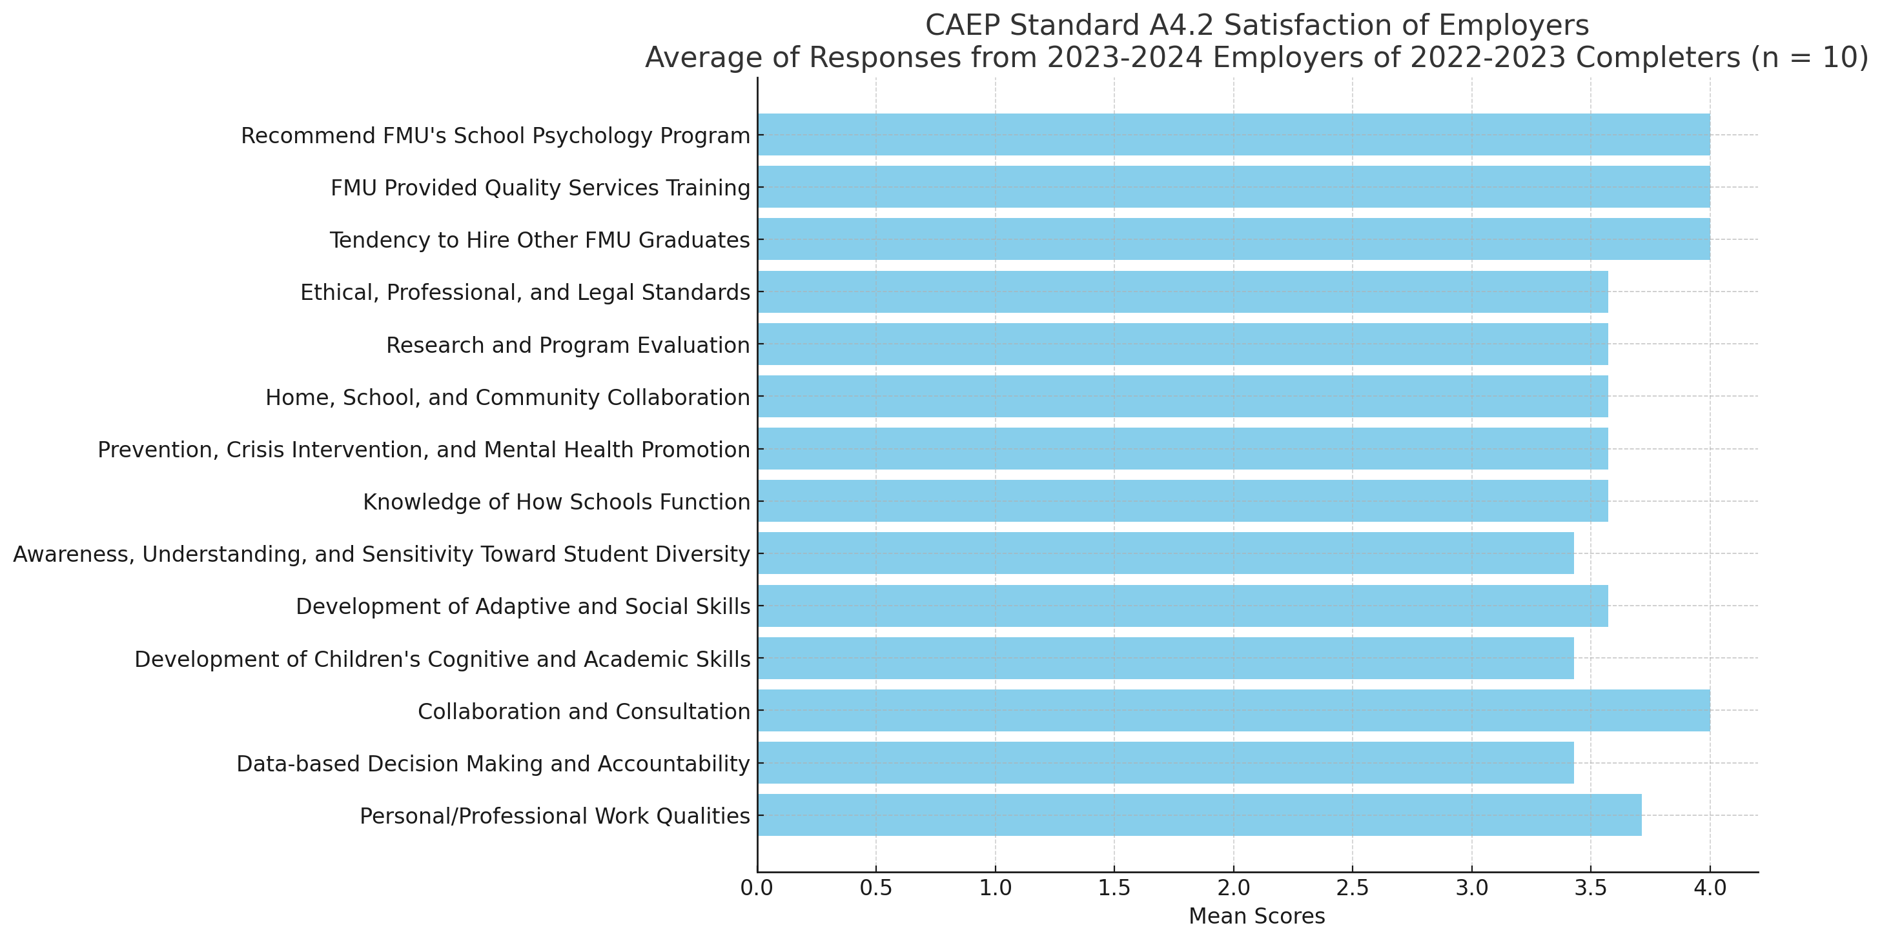

A survey of the employers at FMU indicates that further explicit instruction is needed to address the legalities of IDEA, ensuring that all school psychology candidates have a strong foundation in this area. Employers commented positively on the training in behavioral and academic interventions and response to intervention, highlighting it as a strong aspect of FMU's program. However, they also noted that more practice with various assessments would benefit the students. Overall, the feedback was very positive, with employers describing the program as great and the entry-level professionals as confident in their skill set.

Specific comments from employers emphasized the need for enhanced practice opportunities in assessments to prepare students better. The EPP will continue to strengthen its program in these areas to ensure that graduates are well-equipped to meet the demands of their roles. Demographic information from the questionnaire indicates that most districts employ multiple FMU graduates, with FMU candidates comprising between 10% to 80% of the workforce in various districts.

Satisfaction of Completers

The Specialist in School Psychology at FMU sent a questionnaire to 10 completers of our program (academic year 2022-2023) who are in their first year as practicing school psychologists (2023-2024). The EPP received 6 responses (60% return rate).

It should be noted that all our candidates were offered employment in the district where they completed their internships, and nine were ultimately hired immediately after their year-long internships. This indicates that the completers were well-prepared and fit well within their respective districts. Additionally, all these completers expressed satisfaction with their preparation and readiness for their roles.

Initially, the questionnaire asked completers to respond to 14 rating scale items determined by the EPP to give insight into their satisfaction and perceived effectiveness (4.2). For the 2021-2022 academic year, an additional rating question was added to directly address completer satisfaction with their preparation at Francis Marion University. In 2022-2023, three additional open-ended items were added to provide specific information regarding strengths, areas of improvement, and other general comments about the program.

The EPP reviewed the survey items and then used Lawshe's Content Validity Formula (Lawshe, C.H. (1975)) to determine which items were associated with the duties required of school psychologists and other professional dispositions that are associated with completer satisfaction. The following items were initially identified, and completers were asked to respond to each of these items with one of the following options: Strongly Agree (SA=4), Agree (A=3), Disagree (D=2), and Strongly Disagree (SD=1):

1. Knowledge of varied models and methods of assessment and data collection for identifying strengths and needs, developing effective services and programs, and measuring progress and outcomes. (2.1)
2. Ability to interpret and report results of problem analysis/psychoeducational assessments and link results to intervention as needed (including the ability to interpret results in a fair and accurate manner, report results to others in a meaningful way that facilitates appropriate interventions, and use results for decision making that fosters positive outcomes for students/clients). (2.1)
3. Knowledge of varied models and strategies of consultation, collaboration, and communication applicable to individuals, families, schools, and systems, and methods to promote effective implementation of services. (2.2)
4. Knowledge of biological, cultural, and social influences on academic skills; human learning, cognitive and developmental processes; and evidence-based curricula and instructional strategies. (2.3)
5. Core knowledge of biological, cultural, developmental and social influences on behavior and mental health, behavioral and emotional impacts on learning and life skills, and evidence-based strategies to promote social-emotional functioning, and mental and behavioral health. (2.4)
6. Core knowledge of school and systems structure, organization, and theory; general and special education; technology resources; and evidence-based school practices that promote learning and mental and behavioral health. (2.5)
7. Core knowledge of principles and research related to resilience and risk factors in learning and mental health, services in schools and communities to support multitiered prevention, and evidence-based strategies for effective crisis response. (2.6)
8. Core knowledge of principles and research related to family systems, strengths, needs, and culture; evidence-based strategies to support family influences on children's learning and mental and behavioral health; and strategies to develop collaboration between families and schools. (2.7)
9. Core knowledge of individual differences, abilities, disabilities, and other diverse student characteristics; principles and research related to diversity factors of children, families, and schools, including factors related to culture, context, and individual and role differences; and evidence-based strategies to enhance services and address potential influences related to diversity. (2.8)
10. Core knowledge of research design, statistics, measurement, varied data collection and analysis techniques, and program evaluation sufficient for understanding research and interpreting data in applied settings. (2.9)
11. Core knowledge of the history and foundations of school psychology; multiple service models and methods; ethical, legal, and professional standards; and other factors related to professional identity and effective practice as school psychologists. (2.10)
12. Professional integrity, involvement, and leadership (including adherence to ethical/legal standards, participation in professional development activities, and demonstration of leadership skills within the district/agency, community, and/or profession). (PROF)
13. Personal/professional work qualities needed for effective interaction with others (including respect for worth and uniqueness of all individuals of varying abilities and disabilities regardless of cultural, ethnic, socioeconomic, gender, and religious backgrounds, ability to interact effectively with children, adults, and families of diverse backgrounds, and ability to establish and maintain collaborative relationships with colleagues/coworkers). (PROF)
14. How well did FMU appear to provide the training needed for you to provide quality services that positively impact children and other clients? (PROF)

Additionally, the completers were asked to respond to this item with one of the following options: Strongly Satisfied (SA=4), Satisfied (A=3), Dissatisfied (D=2), and Strongly Dissatisfied (SD=1).
15. How satisfied are you with the training and preparation you received from Francis Marion University? (Satisfaction x = 3.6, range 3 – 4, mode 4)

Chart S: CAEP Standard 4.4 Completer Satisfaction Questionnaire provides the results for the six completers who returned their surveys.

Chart S
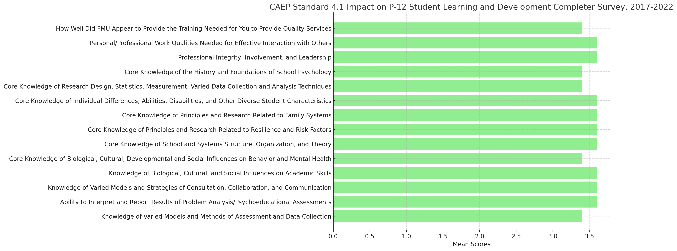
A survey of the completers from FMU indicates that the program provided solid skills in assessments, report writing, interventions, data analysis, consultations, and mock meetings to share results. Completers particularly valued the personalized attention and mentorship offered by the program, which was seen as a significant strength. They also appreciated the program leadership's willingness to review staff and make changes based on professors' strengths and weaknesses.

However, completers suggested several areas for improvement to better prepare students for entry-level positions as school psychologists. They emphasized the need for more classes with quality counseling and mental health instructors, highlighting that mental health services are becoming increasingly essential across all grade bands and are often limited in the community. Completers also recommended integrating instruction throughout the coursework on behavior, including progress monitoring, behavior intervention plans (BIPs), functional behavior assessments (FBAs), and considering trauma in cases.

Another notable area for enhancement was the exploration of test material options for non-English speaking students and the factors involved in determining whether to open an evaluation for multilingual populations. Completers stressed the importance of preparing students for the diverse needs they will encounter in the field.

Overall, the feedback was positive, with completers describing the program as strong and themselves as confident in their skill set. They appreciated the program's strengths in providing practical, hands-on training and its commitment to continuous improvement based on feedback.

Comparative Analysis and Practical Steps for the FMU School Psychology Program

Comparative Analysis of Completer and Employer Feedback
A comprehensive review of the feedback from both completers and employers reveals several common themes and areas for potential improvement in the FMU School Psychology program. Both groups highlighted the program's strengths in training for behavioral and academic interventions and the response to intervention (RTI) process. Completers and employers alike praised the practical, hands-on nature of the training, which has effectively prepared graduates for real-world application in school settings. This alignment underscores the program’s success in providing robust practical training.
However, both completers and employers identified a need for more extensive practice with assessments. Employers noted that while graduates are confident and skilled in many areas, additional practice with assessments would further enhance their readiness. Completers echoed this sentiment, wanting increased hands-on opportunities to refine their assessment skills. This shared feedback points to a clear area for program enhancement.
Another significant theme that emerged is the need for a stronger foundation in the legalities of the Individuals with Disabilities Education Act (IDEA). Both completers and employers highlighted this as an area where graduates could benefit from more in-depth instruction. Completers also noted a specific need for more exposure to Manifestation Determination Review (MDR) meetings, which employers did not explicitly mention but aligned with the broader need for comprehensive legal training.

Qualitative Findings from the Alumni Questionnaire
A survey of the completers from FMU indicates that the program provided solid skills in assessments, report writing, interventions, data analysis, consultations, and mock meetings to share results. Completers particularly valued the personalized attention and mentorship offered by the program, which was seen as a significant strength. They also appreciated the program leadership's willingness to review staff and make changes based on professors' strengths and weaknesses.
However, completers suggested several areas for improvement to better prepare students for entry-level positions as school psychologists. They emphasized the need for more classes with quality instructors in counseling and mental health, highlighting that mental health services are becoming increasingly essential across all grade bands and are often limited in the community. Completers also recommended integrating instruction throughout the coursework on behavior, including progress monitoring, behavior intervention plans (BIPs), functional behavior assessments (FBAs), and considering trauma in cases.
Another notable area for enhancement was the exploration of test material options for non-English speaking students and the factors involved in determining whether to open an evaluation for multilingual populations. Completers stressed the importance of preparing students for the diverse needs they will encounter in the field.
Overall, the feedback was positive, with completers describing the program as strong and themselves as confident in their skill set. They appreciated the program's strengths in providing practical, hands-on training and its commitment to continuous improvement based on feedback.

Closing the Loop: Enhancing Program Effectiveness
To address these themes and close the loop between employer expectations and completer experiences, FMU’s School Psychology program can implement several targeted improvements.

Practical Steps to Enhance the FMU School Psychology Program

Increasing Hands-On Assessment Practice
1. Create dedicated labs equipped with various assessment tools and resources where students can practice administering, scoring, and interpreting assessments under supervision.
2. Implement simulation software and virtual assessment scenarios to provide additional practice opportunities. This will allow students to experience a wide range of assessment situations in a controlled environment.
3. Increase the number of fieldwork hours focused specifically on assessments. Partner with local schools and educational institutions to provide real-world practice opportunities for students.
4. Organize regular peer review sessions where students can practice and critique each other’s assessment techniques and reports, fostering a collaborative learning environment.

Enhancing Legal Training on IDEA and MDR Meetings
1. Add detailed modules on IDEA within existing courses. These modules will cover the legal aspects of special education, procedural safeguards, and compliance requirements.
2. Invite legal experts in special education law to conduct workshops and seminars. These sessions will provide students with in-depth knowledge and the opportunity to ask questions about real-world legal scenarios.
3. Introduce mock MDR (Manifestation Determination Review) meetings into the curriculum. These simulations will allow students to practice conducting MDRs and understanding the legal and procedural aspects involved.
4. Require students to attend at least one actual MDR meeting during their internships. This hands-on experience will provide valuable insight into the practical application of legal knowledge.

Providing Exposure to a Variety of Practical Experiences
1. Ensure students are placed in diverse field settings during their internships. This will expose them to different school environments and a variety of student needs.
2. Strengthen the mentorship program by pairing students with experienced school psychologists who can provide guidance on legal issues, assessment practices, and other professional challenges.
3. Establish a continuous feedback loop with both completers and employers. Conduct regular surveys and focus groups to gather ongoing feedback and make iterative improvements to the program.
4. Offer professional development opportunities focusing on new assessment tools, legal updates in special education, and advanced intervention strategies. Encourage students and alumni to attend workshops, conferences, and online courses.

Enhancing Practical Training and Real-World Preparedness
1. Incorporate detailed case study analyses into coursework. These case studies will cover a range of issues, including assessments, legal challenges, and intervention strategies, providing a comprehensive understanding of real-world scenarios.
2. Foster collaborative projects where students work together to develop and implement assessment and intervention plans. These projects will mimic real-world team-based approaches in schools.
3. Encourage reflective practice by having students maintain journals or portfolios of their assessment and intervention experiences. This will help them critically evaluate their practices and identify areas for improvement.

